# Hierarchy – Data Structures Exam

Your submissions can check here: <https://judge.softuni.bg/Contests/626/B-Trees-and-Red-Black-Tree-CSharp-Exercise>

A **Hierarchy** is a data structure that stores elements in a hierarchical order. See the example:

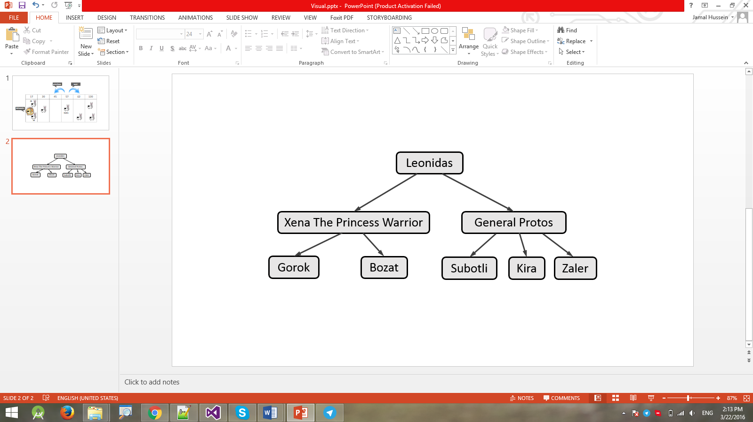

It supports the following operations:

* **Add(element, child)** - adds **child** to the hierarchy as a child of **element**.
  + Throws an exception if **element** does not exist in the hierarchy.
  + Throws an exception if **child** already exists (duplicates are not allowed).
* **Remove(element)** - removes the element from the hierarchy.
  + If it has children, they become children of the element's parent.
  + If element is root node, throws an exception.
* **Count** - returns the count of all elements in the hierarchy
* **Contains(element)** - determines whether the element is present in the hierarchy.
* **Get-Parent(element)** - returns the parent of the element.
  + Throws an exception if **element** does not exist in the hierarchy.
  + Returns the **dafault value for the type** (e.g. **int** → **0**, **string** → **null**, etc.) if element has no parent.
* **Get-Children(element)** - returns a collection of all direct children of the element in order of their addition.
  + Throws an exception if **element** does not exist in the hierarchy.
* **Get-Common-Elements(Hierarchy other)** - returns a collection of all elements that are present in both hierarchies (order does not matter).
* **For-Each()** - enumerates over all elements in the hierarchy by levels.
  + In the image above, the elements would be enumerated as such - **Leonidas** -> **Xena the Princess Warrior** -> **General Protos** -> **Gorok** -> **Bozat** -> **Subotli** -> **Kira** -> **Zaler**.

### Input and Output

You are given a **Visual Studio C# project skeleton** (unfinished project) / **IntelliJ Java project** holding the interface IHierarchy, the unfinished class Hierarchy and **tests** covering its **functionality** and its **performance**.

Your task is to **finish this class** to make the tests run correctly.

* You are **not allowed to change the tests**.
* You are **not allowed to change the interface**.

### Interface IHierarchy

The interface IHierarchy in C# looks like the code below:

|  |
| --- |
| public interface IHierarchy<T> : IEnumerable<T>  {  int Count { get; }  void Add(T element, T child);  void Remove(T element);  IEnumerable<T> GetChildren(T element);  T GetParent(T element);  bool Contains(T element);  IEnumerable<T> GetCommonElements(IHierarchy<T> other);  } |

The interface IHierarchy in Java looks like the code below:

|  |
| --- |
| **public interface** IHierarchy<T> **extends** Iterable<T> {  **int** getCount();  **void** add(T element, T child);  **void** remove(T element);  Iterable<T> getChildren(T element);  T getParent(T element);  **boolean** contains(T element);  Iterable<T> getCommonElements(IHierarchy<T> other); } |

### Submissions

Submit an archive (.zip) of the source code + external libraries.

# Scoring

Each implemented method brings you a specific amount of points, some of the points are awarded for correct behavior, others for performance. You need to cover all tests in a given group in order to receive points. Bellow is a breakdown of all points by methods:

|  |  |  |  |
| --- | --- | --- | --- |
| Method | Correct Behaviour | Performance | Total |
| Add | 3 | 8 | 11 |
| Remove | 4 | 12 | 16 |
| Contains | 3 | 10 | 13 |
| Get Parent | 3 | 11 | 14 |
| Get Children | 3 | 11 | 14 |
| Get Common Elements | 4 | 12 | 16 |
| For Each | 4 | 12 | 16 |
| Overall: | 24 | 76 | 100 |